Sprint 2 - Speed Design Document

November 25, 2019

Anthony Cross, Khadar Estime, Robert Hart, and Isaiah Bishop

**Table of Contents**

**1.** **EXECUTIVE SUMMARY 3**

1.1 Project Overview 3

1.2 Purpose and Scope of this Specification 3

**2.** **PRODUCT/SERVICE DESCRIPTION 3**

2.1 Product Context 3

2.2 User Characteristics 3

2.3 Assumptions 3

2.4 Constraints 3

2.5 Dependencies 4

**3.** **REQUIREMENTS 4**

3.1 Functional Requirements 5

3.2 Security 5

*3.2.1* *Protection 5*

*3.2.2* *Authorization and Authentication 6*

3.3 Portability 6

**4.** **REQUIREMENTS CONFIRMATION/STAKEHOLDER SIGN-OFF 6**

**5.** **SYSTEM DESIGN 6**

5.1 Algorithm 6

5.2 System Flow 6

5.3 Software 6

5.4 Hardware 6

5.5 Test Plan 7

5.6 Task List/Gantt Chart 7

5.7 Staffing Plan 7

# Executive Summary

## Project Overview

The overall idea of this project is to design a code with our team for our robot to successfully complete the speed sprint within our classroom of Howard Hall 208.

## Purpose and Scope of this Specification

The purpose of this project is to complete a flowchart and code for our sphero robot to complete the speed course around our HH208 classroom.

**In scope**

This document addresses requirements related to sprint 2 of our Robotics Project:

* modification of our flowchart and code are needed to meet the requirements for our speed/figure-8 course

# Product/Service Description

The general factors that could affect the product or its requirements are such as:

Group member availability

Algorithm completion

Test Run completion

## Product Context

This speed project is within itself its own code and project, however it also relates with two other parts of a larger project. Which are Sprint-1: Endurance and Sprinit-3: Agility.

## User Characteristics

General User Characteristics:

* Classmates and Professor of Howard Hall 208
* Complete the course and code correctly with robot
* Need to be able to understand sphero app and robot.

## Assumptions

There are many factors and assumptions that could go into the creation of this project, such as:

* Group member availability
* Getting the code correct
* Robot not working correctly

## Constraints

Items that will constrain the design options, including:

* floor texture
* correct code
* room space
* limits on robot use and sign outs
* Sphero app language compared to python language

## Dependencies

Examples:

* Our project needs to be worked on weekly in order to complete the Speed course.
* Our flowchart and code needs to be complete in order to complete the Speed course successfully

# Requirements.

* Priority 1 – Our robot must successfully run the figure eight course 5 times
* Priority 2 – Our robot must stay within the provide path
* Priority 3 – Our robot will start and finish in the square provide
* Priority 4 – Upon finishing, robot will speak ‘I am the winner’ and flash multicolored lights for 5 seconds.
* Priority 5 – Points will be deducted if your robot strays from the path, if it does not go around 5 times, or if it does not finish in the same place it started

## Functional Requirements

|  |  |  |  |  |  |
| --- | --- | --- | --- | --- | --- |
| **Req#** | **Requirement** | **Comments** | **Priority** | **Date Rvwd** | **SME Reviewed / Approved** |
| Speed_01 | Run the course 5 times | Code needs to be correct | 1 | 11/25 | Coder Approved |
| Speed_02 | Stay within provided path | Code needs to be succesful | 2 | 11/25 | Tester 1  Approved |
| Speed_03 | Start and finish in the square | Proper coding | 3 | 11/25 | Tester 2  Approved |
| Speed_04 | When finished, speak ‘I am the winner’ and flash multi lights for 5 seconds | Make sure this is in code and flowchart | 4 | 11/25 | Coder  Approved |
| Speed_05 | Deducted if robot is off path and does not go around 5 times or finish in same spot. | Need to practice course and correct code if wrong. | 5 | 11/25 | All members Approved |

## Security

We are using Github to secure our codes and project, while only the collaborators have access to the project.

# Requirements Confirmation/Stakeholder sign-off

Include documentation of the approval or confirmation of the requirements here:

|  |  |  |
| --- | --- | --- |
| **Meeting Date** | **Attendees (name and role)** | **Comments** |
| 11/22/2019 | Robert Hart, Task Manager and Tester | confirmed all members:  Coder, Tester-01, Tester-02, Task Manager/Tester-03 |
| 11/25/2019 | Anthony Cross, Team Coder  Khadar Estime, Team Tester-01  Isaiah Bishop, Team Tester-02  Robert Hart, Team Task Manager and Tester-03 | confirmed by all team members:  Coder, Tester-01, Tester-02, Task Manager/Tester-03 |

# System Design

This section will provide all details concerning the technical design, staffing, coding, and testing the system

## Algorithm

Develop and describe here the algorithm that will be used to provide the required performance of your software



## System Flow

Sprint-2 Flowchart:

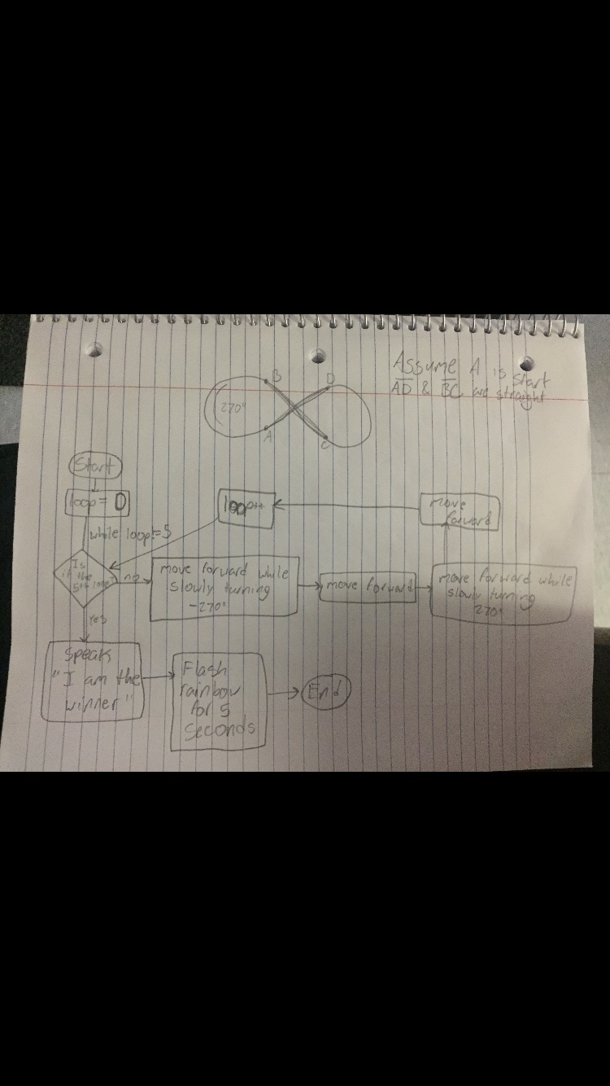

## Software

The sphero app and robot will be used to complete the endurance course.

## Hardware

The sphero app and robot will be used to complete the endurance course

## Test Plan

Include a test plan showing all unit tests performed for this application, Include test rational, test date, staff member, pass/fail status

|  |  |  |  |  |  |
| --- | --- | --- | --- | --- | --- |
| **Reason for Test Case** | **Test Date** | **Expected Output** | **Observed Output** | **Staff Name** | **Pass/Fail** |
| Run the course 5 times | 11/26 | Correct Code and successful run. | Need to fix code | RH/AC | Fail |
| Stay within provided path | 11/26 | Correct Code and successful run. | Get code correct | RH/AC | Fail |
| Start and finish in the square | 11/25 | Correct Code and successful run. | Make code successful | RH/AC | Fail |
| Test code and robot in HH208 | 11/26 | Correct assumptions and codes | Get group together to test code | RH/AC | Fail |

## Task List/Gantt Chart

Sprint 2-Gantt Chart:

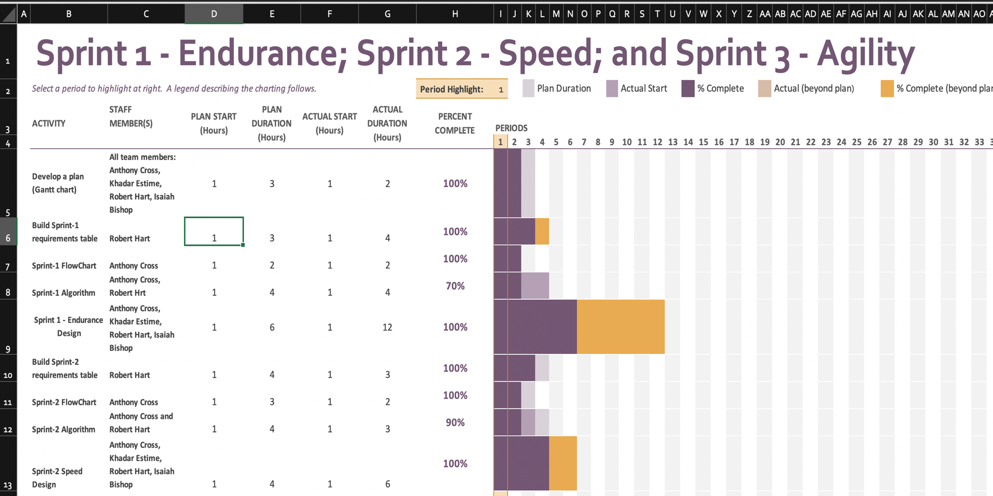

## Staffing Plan

Insert a chart/table that depicts the roles and responsibilities of each team member that worked on this project

|  |  |
| --- | --- |
| Name | Role |
| Robert Hart | Task Manager and Tester |
| Anthony Cross | Coder |
| Khadar Estime | Tester |
| Isaiah Bishop | Tester |